EAGLE LAKE RAINBOW TROUT
Oncorhynchus mykiss aquilarum (Snyder)

Note: This account is part of a statewide assessment of California fishes, which follows a standard format for determining conservation status. It is essential to read the methods section at the beginning of this report to understand how scores were awarded and conclusions were reached.

Status: High Concern. Eagle Lake rainbow trout (ELRT) do not exist as a self-sustaining wild population because of dependence on hatchery propagation. Continued reliance on hatchery production to maintain the Eagle Lake population will make it increasingly difficulty to re-establish a wild population.

Description: This subspecies is similar to other rainbow trout in gross morphology (see Moyle 2002), but differs slightly in meristic counts, especially in having finer scales than coastal rainbow trout. It also is unique in possessing 58 chromosomes rather than the 60 typical of other rainbow trout (Busack et al. 1980).

Taxonomic Relationships: Snyder (1917) described this trout as a subspecies of rainbow trout, Salmo gairdneri aquilarum. However, Hubbs and Miller (1948) examined Snyder's specimens and concluded that Eagle Lake rainbow trout were derived from hybridization between native Lahontan cutthroat trout and introduced rainbow trout. Miller (1950) later retracted the hybridization theory. Needham and Gard (1959) then suggested that Eagle Lake rainbow trout were descended from introduced or immigrant rainbow trout from the Feather or Pit River drainages. Behnke (1965, 1972) proposed a redband-rainbow hybrid origin, although redband trout are now considered to be rainbow trout subspecies. Busack et al. (1980), in an extensive electrophoretic, karyotypic, and meristic analysis, suggested that Eagle Lake rainbow trout were derived either from immigration or an unrecorded introduction of a rainbow trout with 58 chromosomes. Given the distinctive morphology, ecology, and physiology of this form, it is clear that ELRT is derived from natural colonization from the Sacramento drainage. Behnke (2002) speculated that Lahontan cutthroat trout were the original inhabitants of Eagle Lake but that they disappeared during the Pleistocene during an extended period of drought. During a wetter period, rainbow trout managed to invade through an unspecified headwater connection (Behnke 2002). Recent genetic studies (ALFP DNA techniques) suggest that the closest relatives of Eagle Lake rainbow trout are rainbow trout from the Feather River (M. Stephens 2007).

Life History: Eagle Lake rainbow trout are late maturing (usually in their third year for females) and were historically long-lived, up to 11 years (McAfee 1966). Trout older than 5 years are rare in the lake today, although individuals as old as 8-9 yrs have been caught (DFG, unpublished data). Originally, the trout spawned primarily Pine Creek, which flows into the lake on the western shore, and, occasionally, in the much smaller Papoose and Merrill creeks, which feed the southern Eagle Lake. Upstream migrations take place in response to high flows in March, April, or May. In Pine Creek, the main spawning areas were presumably the gravel-bottomed spring-fed creeks, such as Bogard Spring Creek, and headwaters in meadows, such as Stephens Meadows, about 45 km from the lake. Historically, it is likely that the trout spent at least their first 1-2 years of life in these creeks before migrating to the lake, much like coastal steelhead. However, it is possible some became stream resident although capable of producing migratory progeny, similar to steelhead and other lake-dwelling trout populations, such as Goose Lake redband trout (Moyle 2002). In recent years, progeny of adults transported to the upper basin have been found to be as old as four years. It is also possible that ELRT spawned successfully in the lower reaches of Pine Creek, with fry washing into the lake. In 2010, 26 adult spawners were released above the weir in April. In June, fry (30-40 mm TL) were collected from the trap downstream (P. Divine CDFG, pers. comm.). It is not known if these fish can survive in the lake.
Based on growth of yearling ELRT from hatchery plantings, they grew to about 40 cm by the end of their first year in the lake, 45-55 cm in the third, and up to 60 cm in the fifth year (McAfee 1966). These fish could apparently reach 3-4 kg and 65-70 cm FL (McAfee 1966). Data from the last 10 years shows that mature females produce an average of 3,300 eggs (Crystal Lake Hatchery CDFG, unpublished data, 2009). Rapid growth is the result of abundant forage combined with a delay in maturity until 2-3 years of age. This latter trait has made them highly desirable as a hatchery fish (Dean and Chappell 2005).
The life history of these fish has been significantly altered because access to spawning grounds in Pine Creek has been obstructed (see below). Today, as fish move up Pine Creek in the spring, they are trapped at a permanent weir installed by CDFG and artificially spawned. The embryos are then taken to Crystal Lake and Darrah Springs hatcheries where they are reared for 14-18 months. The fish that originated from parents captured in the trap are planted in Eagle Lake at 30-40 cm FL (CDFG, unpubl. data). 180,000-200,000 fish are planted in the lake each year, about half in the lake at the mouth of Pine Creek. In addition, up to 10,000 1+kg ‘bonus’ fish may be planted in the fall and spring for the sport fishery. Progeny of the migrant fish are also reared in other hatcheries in California and planted widely in reservoirs (Carmona-Catot et al,in press).
All trapped fish are marked to prevent sibling crosses (reduce inbreeding), to avoid using fish that have been more than one generation in the hatchery, and to select for longer lived fish to compensate for longevity reductions that may have been caused by past hatchery practices (R. L. Elliott, CDFG, pers. comm. 1998). Formerly, a hatchery program for rearing Eagle Lake rainbow trout was maintained at Mt Shasta Hatchery by using wild-caught fish as brood stock for one generation. The progeny of these fish were originally planted widely in reservoirs of the state and used as a source for brood stock in other hatcheries in California, as well as elsewhere in the western USA. Eagle Lake rainbow trout are prized because of their delayed maturity, rapid growth, and longevity.
Today, all fish used for hatchery production of Eagle Lake rainbow trout are reportedly first generation fish from the Pine Creek trap, although fish from hatchery broodstock were planted in the lake in the past (P. Divine, CDFG, pers. comm. 2009). The fish planted in waters other than Eagle Lake come from the spawning of individuals derived from Pine Creek spawners and raised to maturity in the hatcheries. Fish planted in Eagle Lake originate directly from fertilized eggs taken from Pine Creek spawners. In the past fish of both origins were planted in the lake, as were Eagle Lake rainbow trout of the domesticated hatchery strain.
Despite this long history of hatchery selection, there is evidence that Eagle Lake rainbow trout can still spawn successfully in Pine Creek. Fish that were trucked to the upper reaches of the creek in the 2000s produced young which survived and grew for two years. A thorough survey of Bogard Spring Creek revealed the presence of at least 170 rainbow trout in 2007, with most fish lengths between 105 and 150 mm FL; in 2008, only 25 ELRT were captured with lengths between 130-165 mm FL, while 34 such fish were captured in 2009 (Figure 1; Carmona-Catot et al 2010,in press). These fish survived and grew despite the presence of about 5,300 brook trout in the same reach of stream in which they were found (see management section below for details). There is some evidence that the two year old fish will try to migrate downstream to the lake during periods of high spring flow (P. Moyle, unpublished observations, 2006). In spring 2009, an Eagle Lake rainbow trout was captured in Pine Creek at 800 meters downstream from the confluence with Bogard Spring Creek. This fish was fin clipped in September 2008 in Bogard Spring Creek (Moyle and Carmona, unpublished data). In 2010, a single male trout managed to migrate the entire distance from the weir to the spawning area (T. Pustejovsky, pers. comm.).
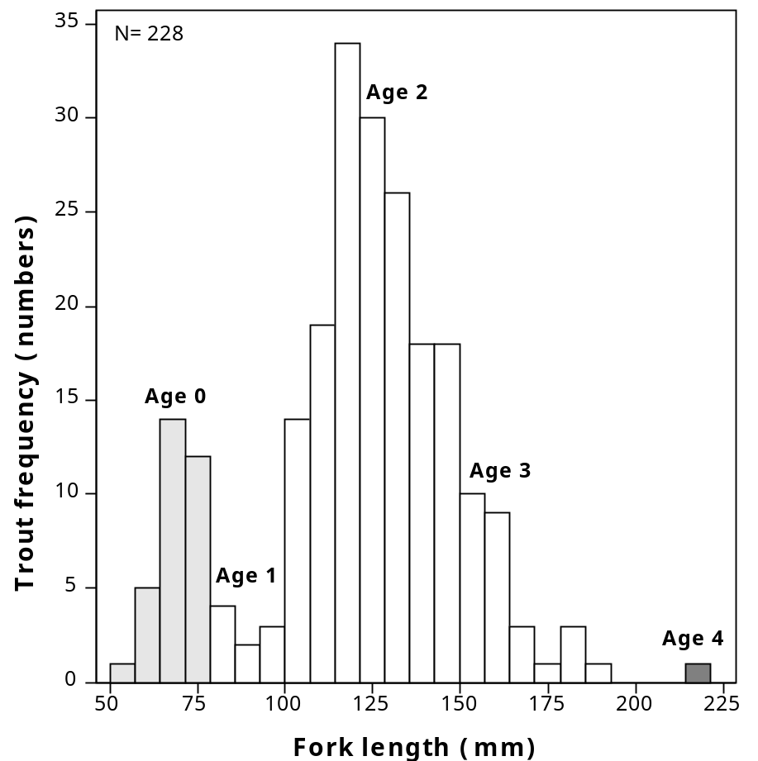

Figure 1. Fork lengths and ages of Eagle Lake rainbow trout in Bogard Spring Creek sampled in 2007, 2008, and 2009. Age distributions are inferred from scales of 71 fish. From Carmona-Catot et al. (in press).

The diet of the trout varies with age and season. Newly planted trout in their first year in the lake feed mainly on zooplankton, including Daphnia spp. and Leptodora kindti, and on benthic invertebrates, especially leeches and amphipods. By August, most of the trout switch to feeding on young-of-year tui chubs (King 1963, Moyle 2002, Eagles-Smith 2006).

Habitat Requirements: Eagle Lake rainbow trout spend most of their life in Eagle Lake, a large (24 km long by 3-4 km wide), highly alkaline lake. The lake consists of three basins, two of them averaging 5-6 m deep, the third averaging 10-20 m with a maximum depth of about 30 m. The shallow basins are uniform in their limnology and water temperatures may exceed 20°C in the summer. The deep basin stratifies, so in late summer most of the trout are in the deeper, cooler water of this basin. Otherwise, they are found throughout the lake.
Eagle Lake rainbow trout are stream spawners. They formerly migrated up to 45-50 km upstream to spawn in the gravelly upper reaches of Pine Creek and its tributaries. Juveniles then spent their first and/or second year in the stream before moving into the lake during high run-off periods that reconnected headwaters to the lake. During the summer, upper Pine Creek is a cold spring-fed trout stream, flowing at .03-0.14 m³/s through meadows and open forest, with modest gradients. Bogard Spring Creek is also a spring-fed creek, with flows of 0.01-0.02 m³/s. The meadow streams have deep pools and glides with deeply undercut banks, providing abundant cover for trout. The Pine Creek watershed is described in detail by Pustejovsky (2007). Unfortunately, the trout present today in the creek are almost entirely alien brook trout, in high densities (Carmona et al. 2010).
Environmental tolerances of Eagle Lake rainbow trout are high for a trout and similar to those of coastal rainbow trout. In Eagle Lake, they live in highly alkaline water (pH 8.4-9.6), in which dissolved oxygen is usually at or close to saturation. They have been observed foraging in shallow water at temperatures of 22-23°C but generally retreat to deeper, cooler (<20°C) as lake temperatures increase. The requirements of spawners and juveniles in streams have not been worked out but are presumably similar to those of other rainbow trout (see Moyle 2002).

Distribution: Eagle Lake rainbow trout are endemic to Eagle Lake, Lassen County, and its main tributary, Pine Creek. They have been planted in numerous waters throughout California, where they are maintained from hatchery stocks originating from trout captured at the weir and fish trap at the mouth of Pine Creek. In the past, hatchery trout have been exported to other states and to Canada. It is unlikely that naturally reproducing populations of genetically ‘pure’ Eagle Lake trout are present in any of these planted waters, although data are largely absent.

Trends in Abundance: Naturally spawned Eagle Lake rainbow trout were once abundant in the lake. According to Purdy (1988), "In the spring months of the 1870s and 1880s, when trout were spawning, huge quantities were being caught. It was not unusual to hear that wagon loads of trout, some weighing as much as 600 pounds, were being brought into Susanville where they were sold at local markets for twenty-five cents a pound (p. 14)." This exploitation occurred at the same time as extensive logging in the drainage, heavy grazing in the meadows, and the first construction of railroad grades and roads across the meadows and streams, all of which altered stream channels. When the ELRT was described by Snyder (1917), he noted its numbers were low. Although commercial fishing for trout was banned in California in 1917, ELRT populations remained low, presumably because of the poor condition of Pine Creek and the establishment of predatory largemouth bass and brown bullheads in the lake. By 1931, trout were scarce in the lake and Pine Creek (Snyder 1940).
During the 1930s, trout populations were stressed as lake levels dropped dramatically when diversion of water through Bly Tunnel combined with prolonged drought to presumably reduced access of spawning trout to Pine Creek. In 1939 biologists in Lassen National Forest expressed concern over impoundments further reducing flows of drought-stricken Pine Creek (Pustjevoksy 2007). Meanwhile, logging, railroad construction, and other activities further degraded the Pine Creek watershed. On the bright side, high alkalinities brought on by dropping lake levels also eliminated bass from the lake, although bullheads persisted into the 1970s. Even with the return of wetter conditions, the trout populations showed little sign of recovery. In 1949 and 1950, DFG collected 35 and 75 adult ELRT, respectively, from the mouth of Pine Creek, spawning them for hatchery rearing (Dean and Chappell 2005). The 258 progeny from the 1949 fish were planted in Pine Creek, where brook trout had recently become established, but probably did not survive. The spawning of fish in 1950 was more successful and the hatchery-reared progeny were planted in the embayment at the mouth of Pine Creek. In 1951-1958, some artificial propagation also took place although the records are not clear as to how many fish were produced (Dean and Chappell 2005). Prior to hatchery propagation, trout presumably persisted only because occasional wet years permitted successful spawning despite degraded stream channels and the presence of brook trout in the spawning reaches (McAffee 1966). It is possible that these actions by DFG biologists prevented extinction of ELRT although it is equally possible, based on recent genetic evidence, that a small migratory population persisted until all access to upstream areas was blocked in 1995.
In 1959, an egg taking station was built at the mouth of Pine Creek, including a wooden weir/dam to block upstream passage of most fish (Dean and Chappell 2005), Regular trapping operations began in 1959, when 16 trout were captured and spawned; in the next five years the numbers captured varied from 45 to 391 (McAfee 1966). From 1959 through 1994, a few trout were able to make it over the barrier during wet years, apparently allowing some natural spawning (Pustejovsky 2007, Moyle, unpublished data).
In 1995, the weir was rebuilt to prevent upstream movement of all ELRT (Pustjevoksy 2007). The life history of the trout then became entirely under human control. At present, eggs and milt are stripped from the fish at the egg taking station. The embryos are then transported to Crystal Lake Hatchery, from where they are distributed to other hatcheries across California (Carmona et al. in review). Originally, trout were marked to prevent using fish that been used for spawning in previous years, to prevent sibling crosses and thus minimize inbreeding, and to select for longer lived fish to compensate for longevity reductions that may have been caused by past hatchery practices (R. L. Elliott, California Department of Fish and Game (DFG), pers. comm. 1998). Today, the main process is simply to stock only progeny of wild-trapped fish in the lake. At the Mount Shasta Hatchery, broodstock trout are reared from eggs collected at the Pine Creek egg taking station; once mature, the broodstock are used for multiple spawning seasons to produce trout which are stocked widely across California, mainly in reservoirs.
Although progeny of first generation broodstock were planted in Eagle Lake in the past, DFG currently stocks only trout from eggs annually collected at the station (P. Divine, DFG, pers. comm., 2009; DFG, unpublished data). Each year, approximately 180,000 - 200,000 trout weighing about 0.23 kg (0.5 lb) each and 20,000 1kg+ “trophy fish” are stocked in Eagle Lake for the fishery. To provide fish for planting, hundreds of trout are trapped each year and between 1 and 6 million fertilized eggs per year are taken for hatchery rearing. Thus in 2009, 1,737 females were spawned, producing 5,985,880 eggs, for the hatchery, while in 2008 the take was 2,757,420 eggs, and in 2007, 1,113,980 eggs (Paul Divine, CDFG, personal communication 2009). There is no recent evidence of natural reproduction contributing to the lake population; the fish captured by anglers usually show signs of a year or more in a hatchery environment, mainly fins with distorted fin rays or missing fins.
Prior to 2006, in some years, DFG also has stocked ca. 1000 “half pound” fish in Pine Creek to reduce the brook trout population through predation (Dean and Chappell 2005), although there were no studies to confirm that it worked. Subsequent sampling suggests that few of these fish persisted for long in the creek (Moyle, unpublished data).
Actual population size of trout in Eagle Lake has not been studied but it is presumably dependent on the stocking allotments every year. Creel censuses indicate that catch per hour from 1983 through 2007 ranged from 0.2 to 0.6, with a mean of 0.3, while average length of fish caught increased over the years (Carmona-Catot et al., in press). The number of mature females captured at the trap while migrating and spawned by the DFG ranged from ca 600 to 1,700, although no estimates were made of size of the entire spawning run. The number of eggs collected averages about 2.2 million, with annual takes of 607,000 to 6 million (P. Divine, CDFG. pers. comm.); the egg quotas are developed every year by DFG hatchery personnel in order to achieve the hatchery goals.
Genetic studies provide some insights into minimum population sizes in the lake. Carmona-Catot et al. (in press) found individuals in the lake population had an F_{IS} or inbreeding value, of 0.064, significantly higher than zero, although no genetic evidence of a bottleneck was detected. The effective population size (size of breeding population) was estimated at 1125 fish, with a confidence interval from 151-∞, indicating in all years there was a fairly large population contributing to reproduction. Given the presumed small number of fish used to establish the original hatchery-based population, it is interesting that no genetic bottleneck was detected. The original bottleneck could have been masked by the number of generations that have passed since the bottleneck and efforts of the hatchery breeding program to maximize genetic diversity (by breeding as many individuals as possible), as seen in the population’s now high effective population size. It is also possible that the population left in the lake in the 1950s was larger than trapping efforts on Pine Creek indicated and multiple years of naturally-spawned fish contributed to the initial hatchery stock. The slight if significant F_{IS} value is still something to be concerned about and to monitor, although it is comparable to levels found in other lake-stream systems in the region such as Goose Lake (Simmons 2011).
Overall, the population appears to be stable because it is maintained entirely by hatchery production, which may be selecting against fish capable of reproducing naturally. For example, Chilcote et al. (2011) show that wild populations of three species of anadromous salmonids from the Pacific Northwest have greatly reduced ability to be self-sustaining when fish of hatchery origin are also present. While the effects of hatchery rearing on trout populations are sometimes overstated, there is ample evidence that it does have an impact on the genetics and behavior of fish released into the wild affecting their ability to persist on their own in the wild (e.g., Waples 1999, Araki et al. 2007, 2008, Kostow 2008). Recent evidence suggests that fitness reductions may not just be limited to fish raised in the hatchery but instead continue into subsequent generations (Araki et al. 2009). The continued dependence of the Eagle Lake rainbow trout on hatchery production assumes that the hatchery program will always be adequately funded and maintained, that a hatchery-dependent population is always going to be desirable, and that restoring the natural life cycle is a secondary, not a primary, goal for conservation of this fish.

Nature and Degree of Threats: The greatest historical cause of the near-extinction of Eagle Lake rainbow trout has been the poor condition of the Pine Creek watershed. The watershed was severely altered as the combined result of logging, grazing, and railroad and road building among other threats. These factors do not operate independently but instead must be viewed in aggregate, along with other less pressing threats (Table 1), as cumulative watershed impacts.

 | Rating | Explanation
Major dams | N/A
Agriculture | Intermediate | Bly Tunnel was built to divert water for agriculture
Grazing | High | This was a major cause of the degradation of Pine Creek watershed but less of a problem today; also affects shoreline of lake.
Rural Residential | Low | Septic discharge into lake
Urbanization | N/A
Instream mining | N/A
Mining | N/A
Transportation | Intermediate | Culverts (now fixed) have been barriers to migration but roads continue to affect Pine Creek and lake.
Logging | Intermediate | Major activity in watershed
Fire | Low | Has potential to negatively impact Pine Creek and watershed
Estuarine alteration | N/A
Recreation | Low | Increasingly recreation is a major human use of the basin
Harvest | Intermediate | Major problem in past; trophy fishery drives management
Hatcheries | High | Almost all fish produced in hatchery for 60+ years
Alien species | High | Brook trout in Pine Creek major barrier to restoration. Alien diseases a possible threat.
Table 1. Major anthropogenic factors threatening viability of the Eagle Lake rainbow trout population in California, where a factor rated “high” is major threat, a factor rated “intermediate” is only a moderate threat, and a factor rated “low” is a low or unknown threat. Certainty of these judgments is high. See methods section for explanation of rating procedures.

Agriculture. In the past, Eagle Lake was looked upon as a potential source of water for the agricultural region around Susanville. This resulted in the construction of Bly Tunnel in the 1920s, to send Eagle Lake water into Willow Creek for use in irrigation. This scheme largely failed to deliver the water promised. During the 1930s lake levels dropped as the result of diversion of water through the tunnel in combination with a severe prolonged drought. Bly Tunnel continues to be a threat to the lake. Although it was blocked off, it still discharges, through an eight-inch pipe in the plug, 0.034 cubic m/s of Eagle Lake water into Willow Creek for downstream water right holders. While some of the water coming from the tunnel may be ground water, most of it is Eagle Lake water because it is chemically similar to Eagle Lake water (Moyle et al. 1991). While the amount is small, it may still be still important to reduce severe alkalinity that is likely in the lake during a prolonged drought.
Grazing. Livestock grazing started in the mid 1800s and was unregulated until 1905. Grazing livestock have been a major problem because cattle gather in and around the creek, although this is less of a problem today because of improved grazing management (Pustejovsky 2007; Carmona-Catot, in press). However, the legacy effects of past grazing continue especially in the lower 40 km of Pine Creek where the streambed has down cut and become enlarged in places, much of the riparian vegetation has been removed, and riparian meadows have presumably become drier, making them more likely to be invaded by sagebrush and similar xeric vegetation. Although stream flow records are lacking, it is likely that Pine Creek flows have also become more intermittent during summer, with spring flows decreasing more rapidly after the snowmelt. At present, the lower creek (below highway 44) usually stops flowing in late May or early June. As a consequence of these reduced flows, spawning adult trout (should there actually be any) have reduced access to the key spawning and rearing areas and have been more exposed to predators and poachers, while juveniles have had reduced opportunity to migrate to the lake. As noted below, many of these problems have been addressed by a multiagency Coordinated Resource Management (CRMP) group and the habitat has been steadily improving (Pustejovsky 2007).
Transportation. The problems created by logging roads and railroads (below) worsened when a highway (State 44) was built parallel to the railroad and forced the stream through several culverts. The combination of culverts and channelized stream created a nearly-impassible velocity barrier for the trout.
. In addition, part of the spring flow of tiny Bogard Spring Creek is still being diverted to provide water for a rest stop facility on Highway 44. This water, while small in amount, has the potential to increase the ability of Bogard Spring Creek to support Eagle Lake rainbow trout juveniles.
Logging Timber harvesting officially started in Lassen National Forest in 1909 although the highest production took place in the 1970s and 1980s. The direct effects of timber harvest may have been small because of the rapid infiltration capacity of the volcanic soils of the region, reducing erosion (Platts and Jensen 1991). However, logging did create erosion-prone roads, and resulted in railroads being constructed across the Pine Creek drainage in the 1930s and 1940s, restricting flow of the creek and channelizing the streambed.
Fire. Fires are common in the dry forests of the Eagle Lake watershed. The effects of fire on Pine Creek and its fishes have not been recorded but the potential exists for severe damage to the upper watershed, with subsequent erosion, and perhaps direct mortality of fish in small streams.
Recreation. The major use of Eagle Lake and its watershed is increasingly for recreation, which has some potential for damaging Pine Creek through off-road vehicle use and for damaging restoration efforts through illegal harvest of spawning fish, etc. So far,there is little evidence of this, however,
Harvest. As indicated above, in the 19th century, Eagle Lake rainbow trout were once heavily exploited by a commercial fishery, which probably contributed to its initial decline. Since the 1950s, however, demand for the trout in the lake sport fishery has been the principal reason its population has been maintained by hatchery production. There is concern that if too many spawners are allowed to run wild, hatchery production will decrease, resulting in fewer trout be planted in the lake. This is despite the fact that a high percentage of the production today is planted in places other than Eagle Lake and that the actual carrying capacity of the lake for rainbow trout is not known. It may be that planting fewer fish would result in higher survival rates of the planted fish and more rapid growth rates. If a run becomes re-established in Pine Creek, the trout fishery in the creek will have to be managed in ways that do not effect recruitment to the lake.
Hatcheries. Eagle Lake rainbow trout are most likely completely dependent on hatchery production for survival (Moyle 2002). Prior to the1950s, they presumably persisted only because occasional wet years permitted access to upstream spawning areas through degraded stream channels and because the fish were exceptionally long-lived for rainbow trout. The danger in the present program is that fish are being selected for survival in the early life history stages in a hatchery environment, rather than in the wild, perhaps for early spawning (as has happened in steelhead, Araki et al. 2007). In addition, fish may have been directly selected for large sizes for planting the lake (Carmona-Catot et al. submitted). However, sizes of angler-caught fish appear to be fairly static over the years (Figure 2).

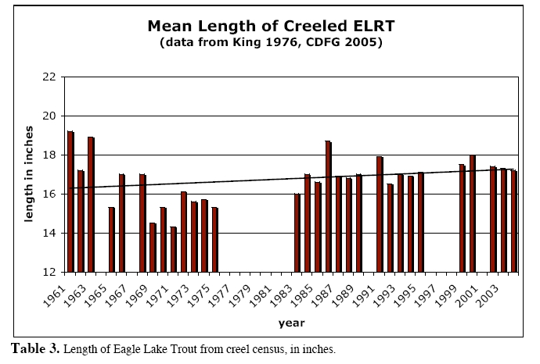

Figure 2. Mean lengths of Eagle Lake rainbow trout caught by anglers, 1961-2005 (from Pustejovsky 2007)

Genetic change has almost certainly occurred as the result of continued hatchery selection, which may reduce the ability of trout planted in the lake to spawn naturally and produce young that can survive in streams. Complete dependence on hatcheries for maintaining the species is undesirable because survival of the species then becomes dependent on vagaries of hatchery funding and management. Survival is further threatened by disease in hatcheries, loss of adaptation for life in the wild, loss of life history diversity, and inbreeding. National Marine Fisheries Service guidelines indicate that a salmonid population dependent on hatchery production cannot be regarded as viable in the long term (McElhaney et al. 2000), a policy supported by recent studies (e.g., Chilocote et al. 2011). The CRMP for Pine Creek (Pustejovsky 2007), if carried out completely, will result in a stream capable of supporting a self-sustaining wild population of Eagle Lake rainbow trout again. However, hatchery production to sustain the trophy fishery currently is regarded as a higher priority than re-establishment of a wild population (Dean and Chappell 2005). This priority is likely to shift only if brook trout are eliminated from Pine Creek so high production of juveniles can be assured (P. Divine, CDFG, pers. comm. 2011).
Another threat to the survival of Eagle Lake rainbow trout is exotic disease, which could be introduced in the hatcheries or into the lake by hatchery-reared fish, and which could foreseeable cause the elimination of most hatchery stock through an epidemic.
Alien species. Many different species have been introduced into Eagle Lake in the past, but none have persisted because of the lake's alkalinity. However, because of Eagle Lake's large size and accessibility, it is likely that other species will be introduced illegally and eventually one may succeed, altering the ecology of the lake. Ironically, introduced species are most likely to become a problem if lake levels rise and alkalinity decreases, as happened in the early 1900s, when largemouth bass and brown bullhead became abundant in the lake (see above). The only alien species in the drainage now is brook trout, which is abundant in Pine Creek. Predation and competition by brook trout in Pine Creek may prevent reestablishment of Eagle Lake rainbow trout, so a program to eliminate this species from the watershed is needed. . The high densities and biomass of brook trout in upper Pine Creek indicates high potential for rearing Eagle Lake rainbow trout in large numbers in absence of brook trout (Carmona-Catot et al 2010,in press) with considerable potential for maintaining large populations in the lake with natural spawning.

Effects of Climate Change: Climate change is likely to have two major impacts on the Eagle Lake watershed: decreasing stream flows and changing lake conditions. Reduced snowpack in the mountains in the Pine Creek watershed will presumably reduce spring outflows, needed for spawning, and the output of springs that feed Pine Creek. The size of this effect, however, will depend on the timing of rainfall and how well meadows are managed to increase their ability to hold water and release it during the summer months. Reduced inflow into the lake could potentially increase alkalinities to lethal levels for trout, although if average precipitation remains roughly the same, the lake should maintain itself. However, the lake today (2011) is now at near-record low levels, so changing water chemistry is a concern. Surface temperatures of the lake could potentially increase 2-3°C but presumably there would continue to be a cold water refuge for trout in the deepest basin of the lake. If climate change produces droughts that dry up Pine Creek early or increase lake alkalinity and temperatures persist for too many years, Eagle Lake rainbow trout could be driven to extinction in its native range, relegating it to a hatchery fish.

Status Score = 2.1. Species of High Concern. While this score reflects our improved understanding of Eagle Lake rainbow trout genetics, the subspecies is likely to go extinct except as a semi-domestic hatchery fish in the next 50 years or sooner if present trends continue, absent successful actions to restore a naturally spawning population (Table 2). Extinction will occur because continued hatchery selection is likely to select against the ability of the fish to maintain a natural life history and/or because of elimination of hatchery stock through a disease epidemic.
A petition for listing as a threatened species was rejected by the USFWS in 1994 (Federal Register 60 (151) 401: 49-40150, August 7, 1994). A similar petition was rejected by the State Fish and Game Commission in 2004. In both cases, the reason given for not listing was insufficient information. The Eagle Lake rainbow trout is currently regarded as a Species of Special Concern and a Heritage and Wild Trout Program by the California Department of Fish and Game and as an R5 Sensitive Species by USFS. The American Fisheries Society lists it as a threatened species, while NatureServe lists it as “critically imperiled” (Jelks et al. 2008).
The Eagle Lake rainbow trout does not exist as a true wild fish and continued reliance on hatchery production for its existence is likely to assure that it will be incapable of becoming re-established as a self-sustaining wild population in the future. Unless significant progress is made to re-establish a naturally-spawning population in the next 5-10 years (by 2021), then listing under the state ESA may be desirable. However, listing could inhibit the ability of local agencies to accomplish restoration tasks quickly and efficiently, by reducing permitting delays. Nevertheless, listing would dramatically underscore the need to connect habitat restoration with re-establishment of a wild population, provide additional incentives to eradicate brook trout, and deal with other problems. It is worth noting that a threatened species designation would not preclude maintaining the fishery in Eagle Lake or elsewhere.

Metric | Score | Justification
Area occupied | 1 | Only one watershed
Estimated adult abundance | 4 | Includes hatchery fish.
Intervention dependence | 1 | Persistence depends on trapping fish for hatchery spawning and rearing.
Tolerance | 4 | One of most tolerant, long-lived kinds of trout
Genetic risk | 3 | Hatchery rearing presumably has changed genetics; accidental hybridization in hatcheries possible
Climate change | 1 | Reduced stream flows or increased alkalinity of lake could endanger fish further.
Anthropogenic threats | 1 | See Table 1
Score | 2.1 | 15/7
Certainty (1-4) | 4 | Well documented although limited peer reviewed literature
Table 2. Metrics for determining the status of Eagle Lake rainbow trout, where 1 is a major negative factor contributing to status, 5 is factor with no or positive effects on status, and 2-4 are intermediate values. See methods section for explanation of scoring procedures.

Management Recommendations: The management of Eagle Lake rainbow trout is an ideal place to institute principles of adaptive management, where management actions are treated as experiments to inform future management (Carmona-Catot et al. in press). The first step in the adaptive management process is to make restoration of a wild, naturally-spawning population a higher priority than maximizing egg ‘take’ for hatchery reproduction. There is no reason to think that a substantial take of eggs for hatchery purposes could not take place even if 10-20% of the adult fish were diverted for natural spawning and for experimental migration studies, especially because hundreds of thousands of fertilized eggs and fish are sent to other hatcheries to rear and to stock in waters other than Eagle Lake. The initial studies (including on-going studies) should have three basic hypotheses driving management actions:
H1: Eagle Lake rainbow trout can successfully migrate upstream from the lake in most years and successfully spawn.
H2: Juvenile rainbow trout can survive and grow in the presence of dense populations of brook trout.
H3: Progeny from natural spawning can return to the lake and contribute to the fishery.

Given that Eagle Lake rainbow trout have gone through more than 60 years of selection for reproduction and survival under hatchery conditions for a significant part of their life cycle, it is imperative to start reversing that process as soon as possible. This has long been recognized and was one of the justifications for the formation of the CRMP group in 1987, followed by many projects on the creek to improve flow and remove passage barriers (Pustejovsky 2007). It is likely that initially a program of trapping and trucking adults and juveniles past low-flow parts of the creek will be necessary. Recent research demonstrated that trapping and trucking is a viable option for helping to recreate a naturally reproducing population; the study suggests that if spawners are allowed to go upstream naturally early in the season they could successfully spawn and perhaps emigrate back to the lake as well following spawning (Carmona-Catot et al.,2010, in press). In 2011, at least one tagged trout was shown to be able to migrate from the weir to the upper creek (T. Pustejovsky, pers. comm.). The costs of alternative management would presumably be comparable to costs of rearing hatchery fish but with fewer genetic consequences (e.g., Waples 1999, Araki et al. 2007, Kostow 2008).
It will also be important to modify the weir on Pine Creek to allow for volitional passage of trout during periods of high flow. There is already evidence that Eagle Lake rainbow trout, at least during wet years, can make it up to the spawning areas and spawn successfully. In the 1980s, a few juvenile rainbow trout were found below Stephens Meadow; suggesting adults made it over the weir and migrated upstream (Moyle, unpublished data). In 1999-2005, biologists from DFG, USFS and U C Davis placed radio transmitters in a small number of adult fish, which were released above the weir (L. Thompson, UC Davis, pers. comm.). In 1999, one of these fish apparently made it into the Pine Creek headwaters, as its transmitter was recovered in Bogard Springs Creek, a tributary to Pine Creek above the highway (T. Pustejovsky, pers. comm.). In 2002-2006, Paul Chappell of DFG released a few ripe trout from the fish trap into Pine creek above highway 40.
In September 2006, a crew from UC Davis, DFG, and USFS sampled Pine Creek to look for Eagle Lake rainbow trout (Moyle, unpublished data). They found evidence that the trout had spawned successfully in the creek in the past two years, because small numbers of young were found at several locations in Pine Creek. About 100 m of Bogard Spring Creek were electrofished and 10 juvenile rainbow trout (76-90 mm FL) were captured along with about 170 brook trout or varying sizes. Presumably the rainbow trout were YOY or yearlings. The rainbow trout tended to be in faster water than the brook trout, in reaches with deep overhanging cover. The UC Davis crew also found 3-4 small rainbows in Pine Creek below the Bogard Spring Creek confluence, as well as a couple of rainbow trout in the 145 mm range living in a creek filled with brook trout of all sizes, speckled dace, Lahontan redside, and Tahoe sucker. Curiously, several of the large trout from the lake that had been planted in the spring were still surviving in the pool below the culvert under Highway 44. Likewise, three spawners were found alive in a culvert about 5 km below the highway, in a largely dry stream (no flow), along with a rainbow trout that was 142 mm SL. In 2007 at least 10 large ELRT (40-50 cm FL) were found downstream from the gauging station weir on Pine Creek (G. Carmona-Catot, pers. comm.).
In 2007, 2008, 2009,and 2010 Bogard Spring Creek was electrofished to remove brook trout to see if spawning success of transplanted adult rainbow trout could be increased and to assess whether a three-pass electrofishing removal can successfully depress brook trout populations. In 2007, 4887 brook trout were removed from the 2.5 km long creek (ca. 2000 fish /km), which is remarkable considering the creek is less than 1 meter wide for all of its length and mostly less than 40 cm deep. During 2007, 170 juvenile Eagle Lake rainbow trout were captured and returned to the creek; most fish were under 150mm FL which indicates that they were not hatchery fish planted in the stream by DFG at larger sizes (Carmona-Catot et al. 2010). Similar results were obtained in following years, along with evidence of greatly a diminished brook trout population. This evidence strongly indicates that a wild spawning population of Eagle Lake rainbow trout can be reestablished through translocation, especially if brook trout populations are largely eliminated.
In part because of the interest in Eagle Lake rainbow trout, major efforts have been made in recent years to fix passage problems in Pine Creek, through the CRMP process (Pustejovsky 2007). As a result sections of the creek have been fenced to keep out livestock, off-creek watering stations have been provided, an impassible culvert under Highway 44 has been replaced with a passable one, and a structure to divert water in from Pine Creek near the Bogard Campground has been removed (and the meadow fenced). However, the meadows along the lower Pine Creek and Bogard Spring Creek are still grazed by cattle, potentially affecting instream habitat and the ability of the meadows to store water that can leak into the creek. With this information in mind, elements of a adaptive management strategy for the trout should include:
- Develop a management plan that is flexible enough to be adapted to changing conditions, that includes a genetic management plan to maximize the possibilities of enhancing genotypes and phenotypes for adapting to local conditions. A basic assumption of the management plan will be that both a hatchery based and wild spawning populations will be maintained, as mutual insurance policies.
- Develop an eradication strategy for brook trout in Pine Creek using either piscicides or other means. A first step is to conduct a thorough investigation of the aquatic insect fauna of the creek to determine potential impacts of piscicides on the insects.
- Make restoration of a wild, naturally-spawning population a higher priority than maximizing egg ‘take’ for hatchery production
- Make the permanent weir at the mouth of Pine Creek a temporary or partial barrier, allowing part of population to move upstream for spawning.
- Starting immediately, release early-spawning adults into the creek above the weir, to maximize potential for natural migration and spawning. This should be the highest priority for the use of trout captured at the Pine Creek weir.
- Establish an annual trapping and trucking operation for both adults and out-migrating juveniles until there are signs the population is self-sustaining and habitat has improved.
- Continue habitat improvements to Pine Creek with the goal to ultimately turn it back into a stream that flows well into the summer for more of its length, if possible, following the recommendations in Pustejovsky (2007). A key is reducing grazing and other impacts.
- Develop Bogard Spring Creek into an experimental spawning stream by constructing a weir/trap at the lower end and then eradicating brook trout through electrofishing and other means.
- Increase flows of Bogard Spring Creek by eliminating the diversion that provides water to the rest station on Highway 44.
- Conduct annual monitoring of fish populations in the creek to determine spawning success, as well as monitoring habitat conditions.
- Test passage improvements to determine if adult trout can in fact pass through all the former barrier areas, by studying movements of radio-tagged mature fish from a natural run.
- Reduce livestock use of riparian meadows even further.
- Acquire the water rights to Eagle Lake water now being diverted through Bly Tunnel and shut off the flows completely (if possible), at least during times of drought when lake levels are dropping.
- Determine the feasibility of using Papoose Creek for establishment of a small spawning population.
- Conduct a thorough study of the survival and growth of trout planted in Eagle Lake, to determine its actual carrying capacity for the trout. Planting of trout in the lake (150,000+ per year) is based on maintaining catches of at least 0.4 fish per hour (Dean and Chappell 2005) rather than on scientific information. It is possible that planting fewer trout may actually improve trophy angling.

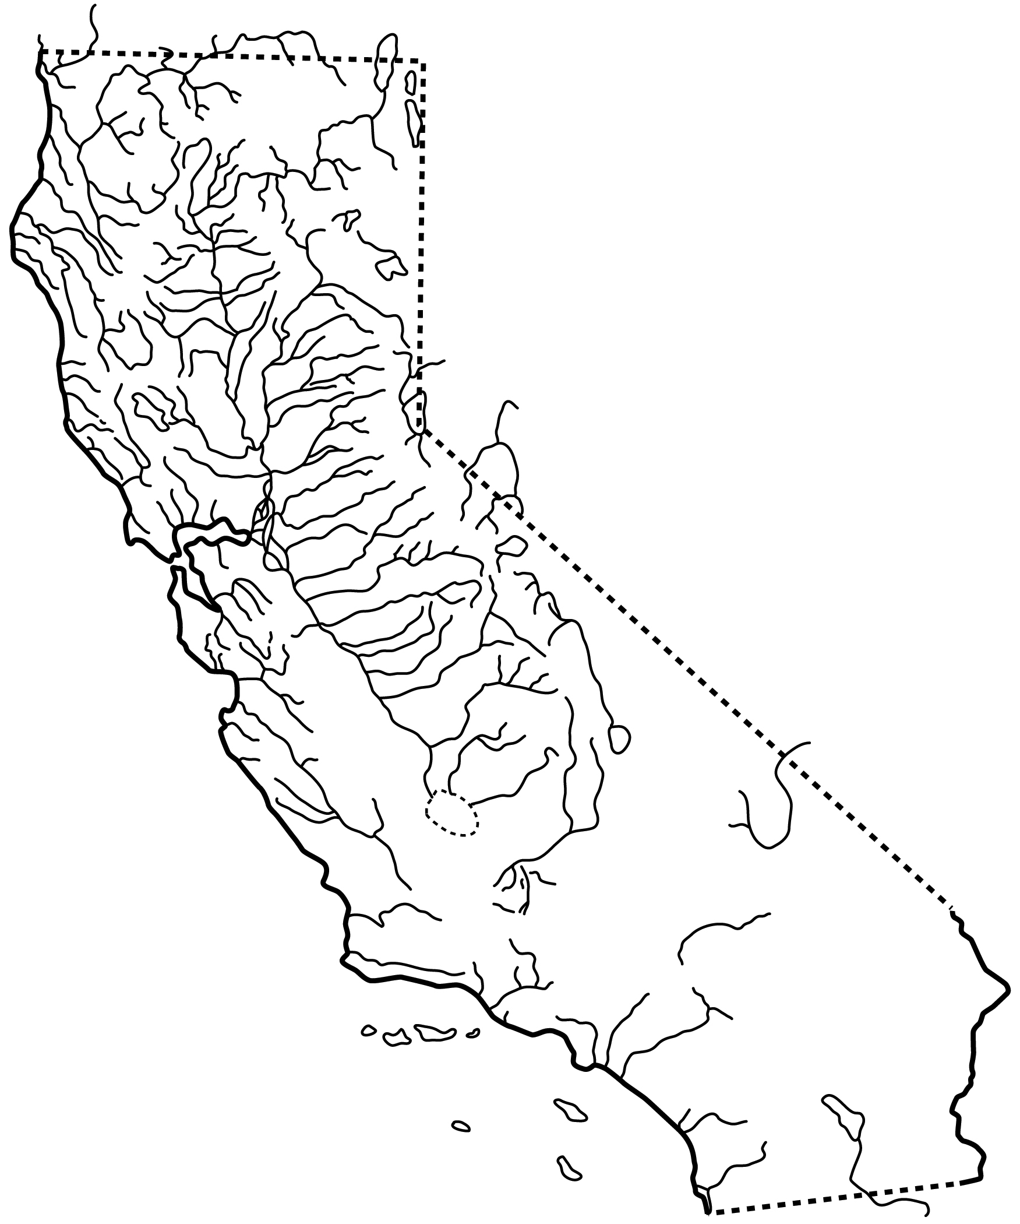

Figure X: Distribution of Eagle Lake rainbow trout, Oncorhynchus mykiss ssp., in Eagle Lake, California.

